Release Note

Kill Sessions

# 1 Basic Details

|  |  |
| --- | --- |
| Customer |  |
| Customer Name | N/A |
| Customer PM  (Where appropriate) | N/A |

|  |  |
| --- | --- |
| Release Control |  |
| Reference No. | MA004 |
| Author | Marcus Ambra |
| Release | 2004-01R |
| Risk Level | Low |
| Release Date | 17/04/2020 |
| Release Media | FOB |
| Release Reason |  |
| Database Version | Dynamics NAV 2018 (11.0.24742) |
| Package Name | NA |
| Delivery Method | NA |
| Customer Approval  (Delivery) | NA |

|  |  |
| --- | --- |
| Work Detail |  |
| Project Name | Kill Session |
| Project Manager | NA |
| Project Phase | Project |
| Person (Developer/Consultant) | Marcus Ambra |
| Functional Area | Administration |
| Reviewer/Approver (Peer/Senior) |  |
| Design Reference | NA |
| Development Release note no. | NA |

# 2 Overview

Created functionality which allow you to kill the user session.

# 3 Technical Details

## 3.1 Summary of Solution Modifications

**Page: 9506-Session List**

**Action Page:**

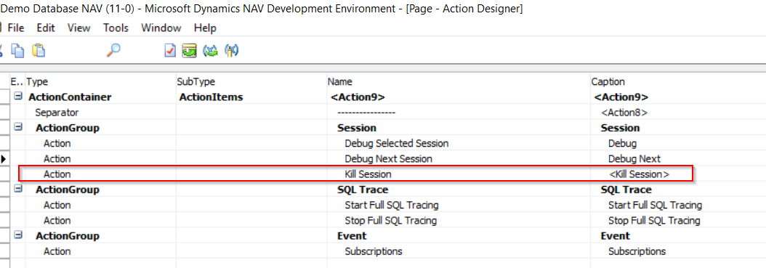

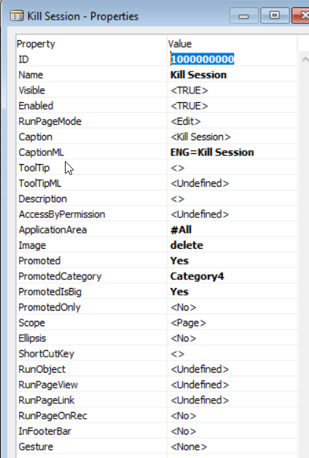

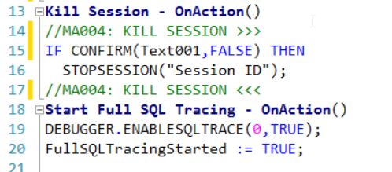

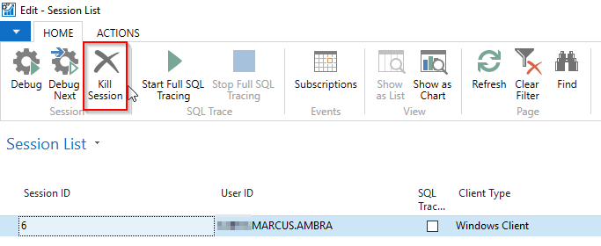

### 3.1.1 Modifications

The following new modifications have been completed and tested:

|  |  |  |  |
| --- | --- | --- | --- |
| Reference | Source | Type | Summary |
|  |  |  |  |

## 3.2 Object Changes

**Important Note**: If there is any discrepancy between the Original Object details and the corresponding Object Details in your database, please do not import them, but inform immediately with details.

### 3.2.1 Object Verification

|  |  |
| --- | --- |
| Source database object changes were developed in |  |
| Date development objects compared to live | 17/04/2020 |

### 3.2.2 Existing

|  |  |  |  |  |  |  |
| --- | --- | --- | --- | --- | --- | --- |
| Object Type (table, form, etc.) | Object ID | Name | Modified | Version | Date | Time |
|  |  |  |  |  |  |  |

### 3.2.3 New

|  |  |  |  |  |  |  |
| --- | --- | --- | --- | --- | --- | --- |
| Object Type (table, form, etc.) | Object ID | Name | Modified | Version | Date | Time |
|  |  |  |  |  |  |  |



## 4. Post Deployment Testing Steps

Please ensure your testing is proportionate to the level of risk.

### 4.1 To Test Code

### 4.2 To Test Data Fix

Not required

# 5 Quality Assurance

## 5.1 Testing Completed

NA

## 5.2 Code Review / Testing

|  |  |  |
| --- | --- | --- |
|  | Name | Date completed |
| Unit Test completed by | Marcus Ambra | 17/04/2020 |
| Code Review completed by | Marcus Ambra | 17/04/2020 |
| Testing completed by | Marcus Ambra | 17/04/2020 |
| UAT testing completed successfully | Marcus Ambra | 17/04/2020 |

# 6 Sign Off

|  |  |  |  |
| --- | --- | --- | --- |
| Action | Name | Signature | Remarks |
| Released By | Marcus Ambra | Marcus Ambra |  |
| Approved By |  |  |  |

All objects/changes moved in to your live environment by yourself or otherwise, are considered complete and approved. Any further changes required after this stage may be considered a new change request.

Please be aware that objects/changes not moved into your live environment within a reasonable amount of time, upon completed user acceptance testing, may cause conflict with other objects/changes.